1. Creating and Renaming Files/Directories

Create a directory named test_dir using mkdir.

Inside test_dir, create an empty file called example.txt.

Rename example.txt to renamed_example.txt using mv

Code:-

1. mkdir test_dir :- make directory with the name of test_dir
2. ls :- to check the list of files in the directory
3. cd test_dir :- to get into the test_dir directory
4. ls
5. touch example.txt :- to create a text file
6. ls
7. mv example.txt renamed_example.txt :- to rename the text file from example.txt to renamed_example.txt
8. ls
9. cd .. :- to go back to previous directory
10. ls

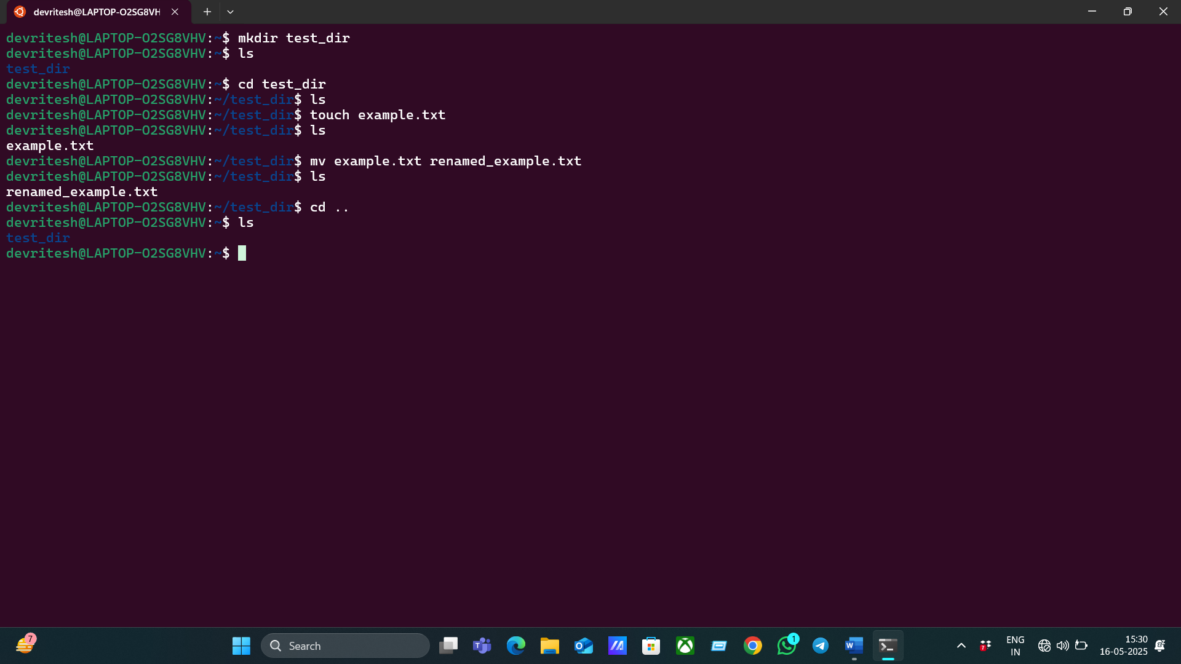

2. Viewing File Contents

Use cat to display the contents of /etc/passwd.

Ans :- Cat command shows all the content of the file .

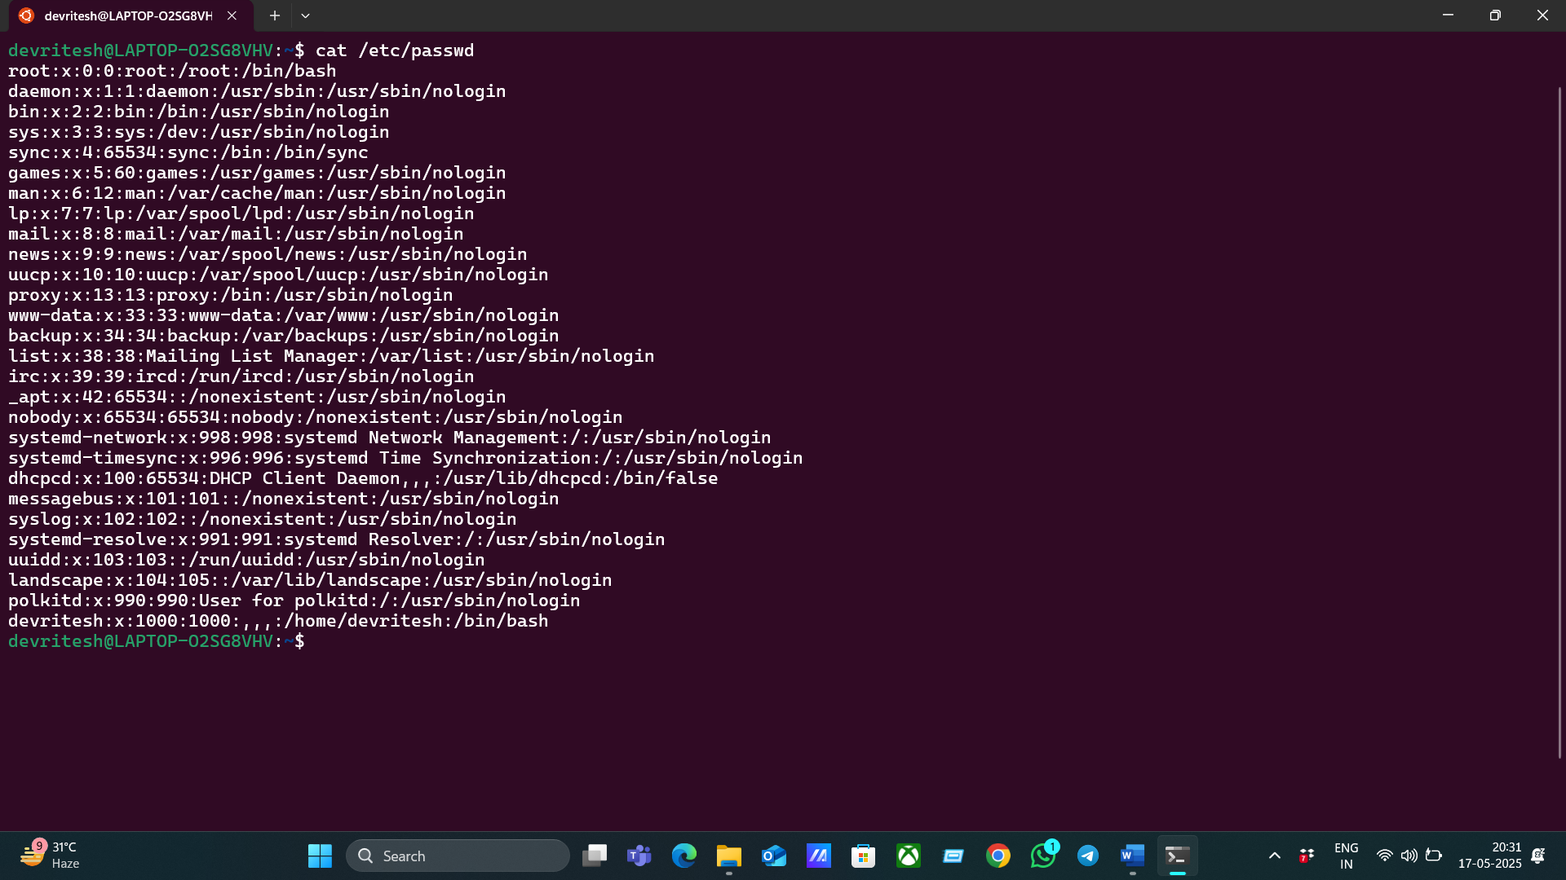

Display only the first 5 lines of /etc/passwd using head.

Ans:- For showing the first 5 lines of the /etc/passwd file , we use “head -n 5 /etc/passwd” command for it.

Display only the last 5 lines of /etc/passwd using tail.

Ans:- For showing the last 5 lines of the /etc/passwd file , we use “tail -n 5 /etc/passwd” command for it.

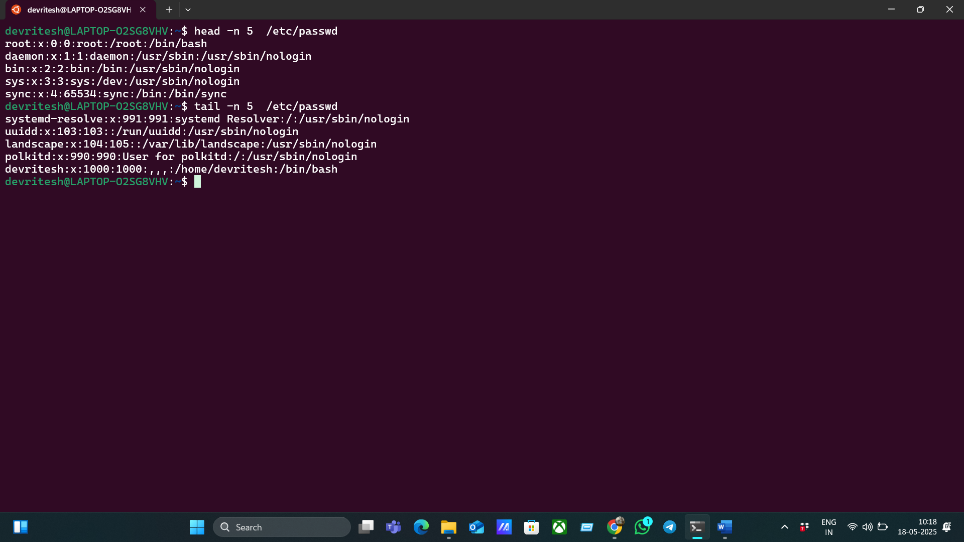

3.Searching for Patterns

Use grep to find all lines containing the word "root" in /etc/passwd.

Ans:- To find or search a particular word or line, we use the “grep” command, which allows us to locate or search for that word or line. So to use it, use the command “ cat /etc/passwd | grep root” to find the lines which are having “root” in them.

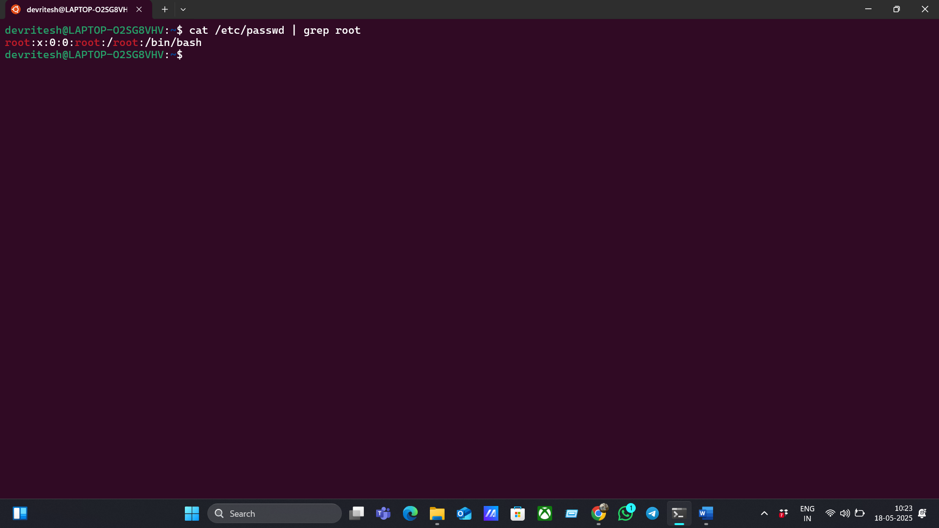

4. Zipping and Unzipping

Compress the test_dir directory into a file named test_dir.zip using zip.

Ans:- To compress a file with the help of the “zip” command, we use “zip -r test_dir.zip test_dir” , which compress the test_dir file to test_dir.zip.

Unzip test_dir.zip into a new directory named unzipped_dir.

Ans:- To unzip a zipped file, we use the “unzip test_dir.zip -d unzipped_dir” command .

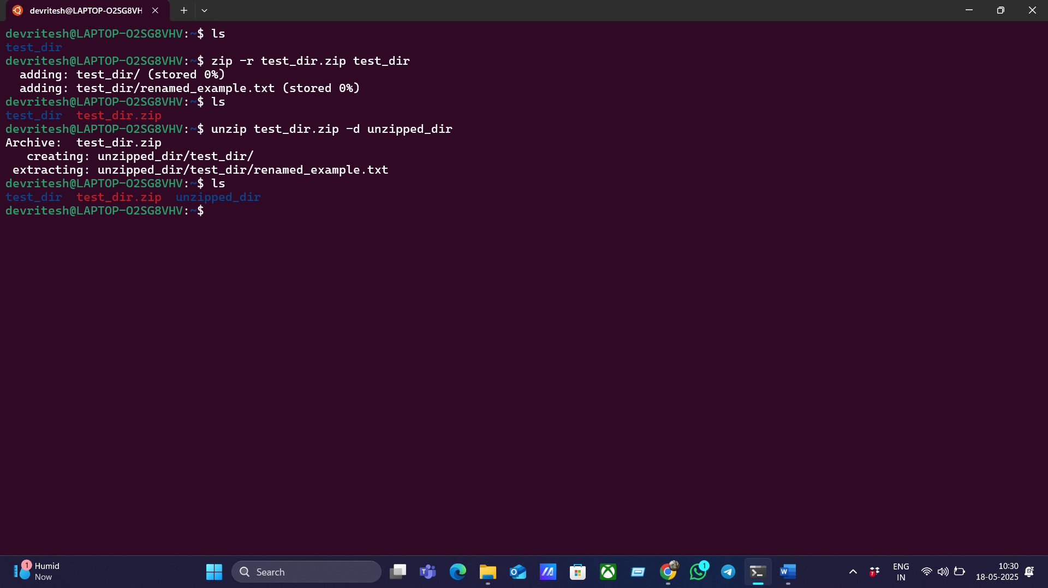

5. Downloading Files

Use wget to download a file from a URL (e.g., <https://example.com/sample.txt>).

Ans:- wget command is used to download the content of the webpage in its original form. So, to use the wget command, type “wget <https://raw.githubusercontent.com/ritesh117/File-Storage-System/refs/heads/main/app.py>” to download the text file.

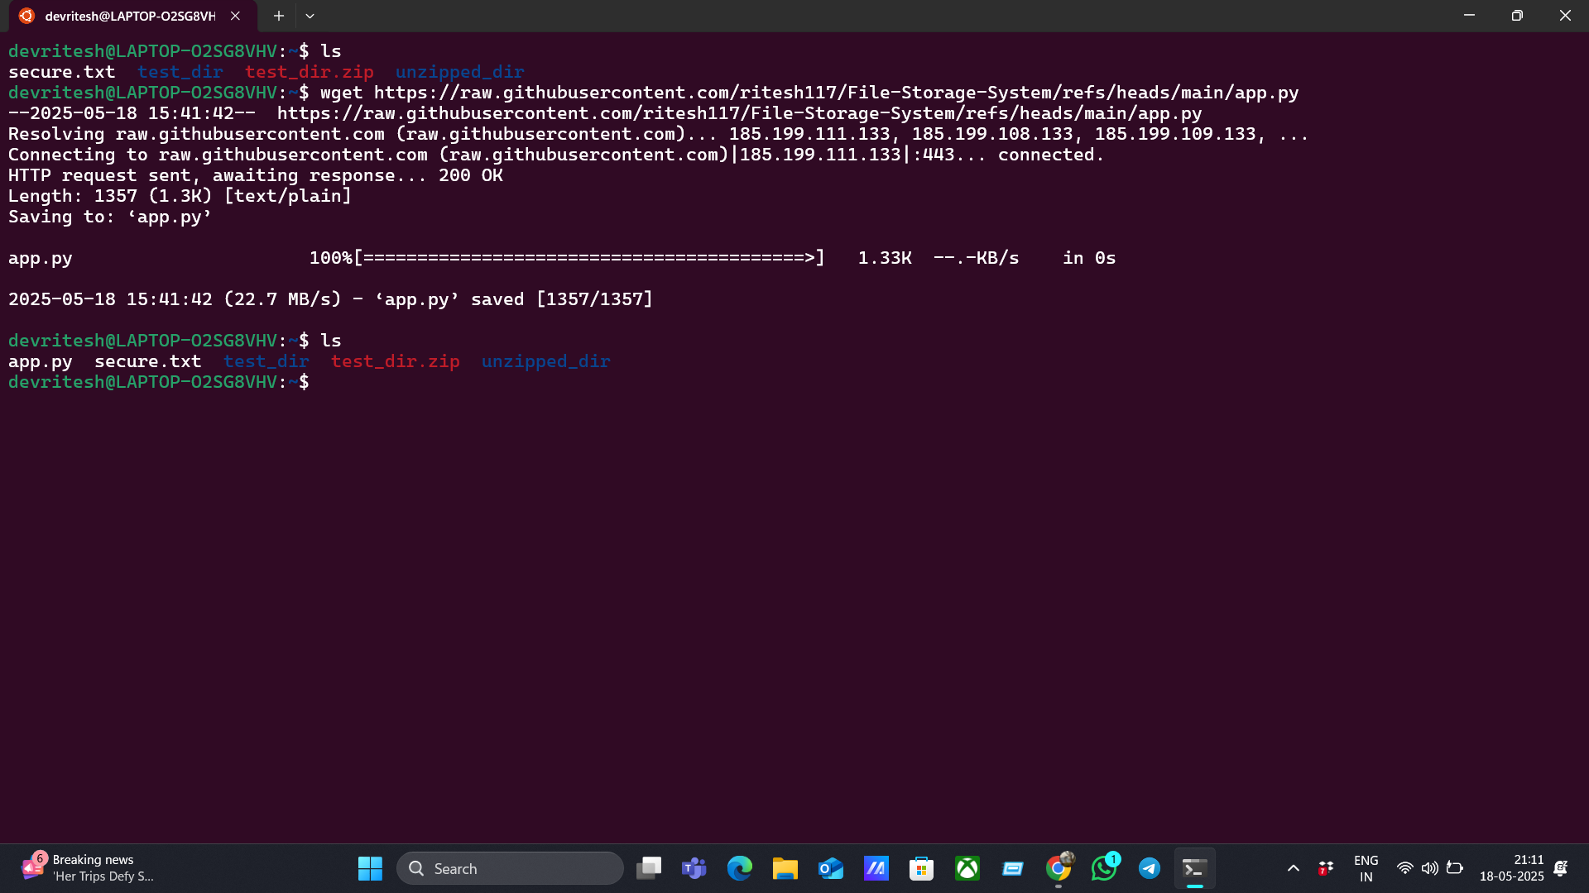

6. Changing Permissions

Create a file named secure.txt and change its permissions to read-only for everyone using chmod.

Ans:- To change the permission of the file according to the user, we use the “chmod” command. So, first we have to create a file named secure.txt by using the touch command, that is “ touch secure.txt” by this our secure.txt file is created. Now, to give the read-only permission to all the users, we use the “chmod a=r secure.txt”. Then we can check it by using he command “ls -l”.

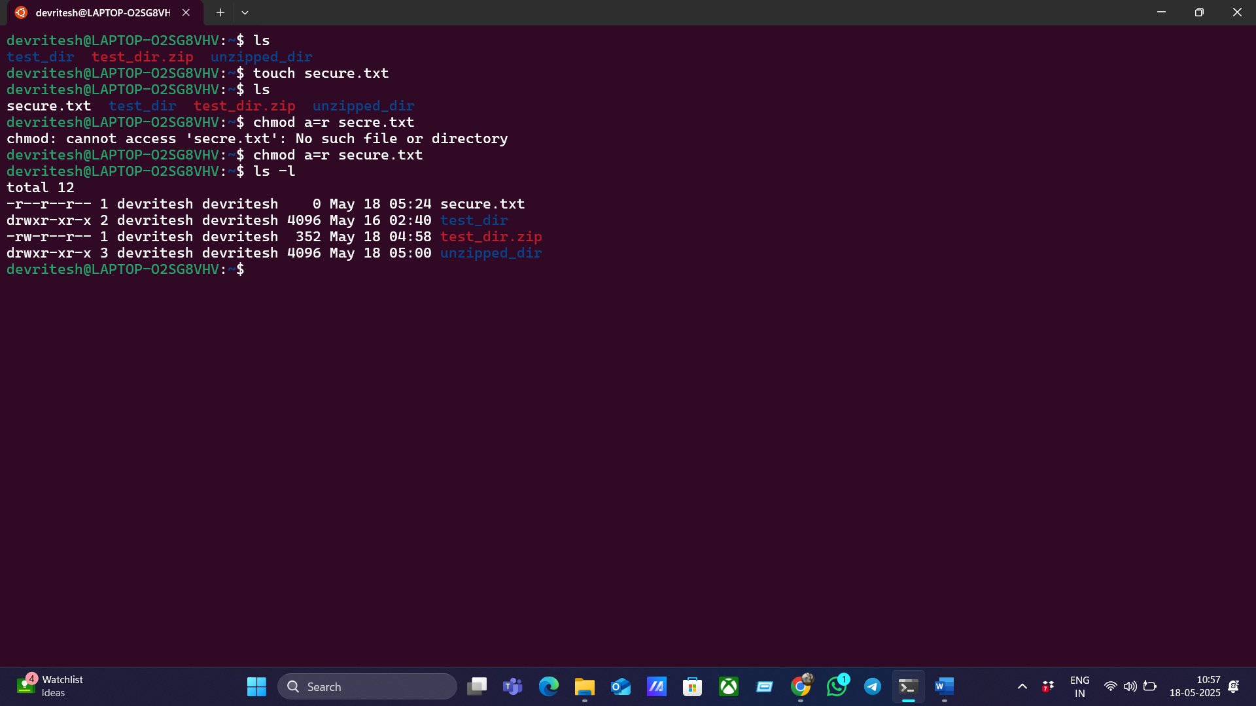

7. Working with Environment Variables

Use export to set a new environment variable called MY_VAR with the value "Hello, Linux!".

Ans:- The export command is used to create an environment in the current working terminal. Users can’t access the content of the exported environment from another terminal. To set a new environment variable, first, we check whether the variable exists or not with the help of the “echo” command. Then we use the export command that is “export MY_VAR=”Hello, Linux!”.

After that, we use “echo MY_VAR” to view the content of the environment.

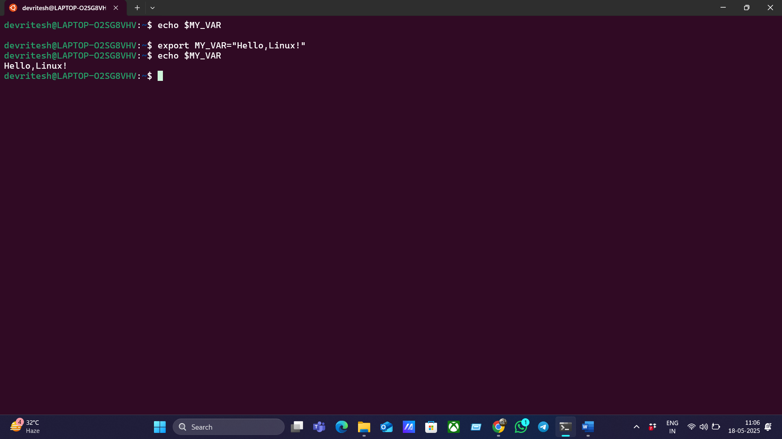

**Submission Guidelines -:** Attach Screenshots or command along with explanation and submit in doc(google doc or microsoft doc) format also attach github repo link